|  |  |
| --- | --- |
| **Course code and name:** | F21DV Data Visualisation & Analytics |
| **Type of assessment:** | **Group** |
| **Coursework Title:** | Coursework 2 |
| **Student Name:** | Callum Mcnee Stewart |
| **Student ID Number:** | H00297039 |

|  |
| --- |
| **Declaration of authorship. By signing this form:**   * **I declare** that the work I have submitted for individual assessment OR the work I have contributed to a group assessment, is entirely my own. I have NOT taken the ideas, writings or inventions of another person and used these as if they were my own. My submission or my contribution to a group submission is expressed in my own words. Any uses made within this work of the ideas, writings or inventions of others, or of any existing sources of information (books, journals, websites, etc.) are properly acknowledged and listed in the references and/or acknowledgements section. * I confirm that I have read, understood and followed the University’s Regulations on plagiarism as published on the [University’s website](https://www.hw.ac.uk/uk/students/studies/examinations/plagiarism.htm), and that I am aware of the penalties that I will face should I not adhere to the University Regulations. * I confirm that I have read, understood and avoided the different types of plagiarism explained in the University guidance on [Academic Integrity and Plagiarism](https://heriotwatt.sharepoint.com/sites/skillshub/SitePages/Academic-Integrity-and-Plagiarism.aspx)   **Student Signature** *(type your name): CALLUM MCNEE STEWART*  **Date**: *13/04/2023* |
|  |

Copy this page and insert it into your coursework file in front of your title page.

For group assessment each group member must sign a separate form and all forms must be included with the group submission.



***Data Visualisation and Analytics (F21DV) – Coursework 2 Report regarding 2021 Season of Formula 1 using D3js***

**Callum Mcnee Stewart**

Student ID: H00297039

Video Link: <https://www.youtube.com/watch?v=DxjyKuILf5M>

GitHub Link:

Introduction

Coursework 2 tasked students to create a narrative of regarding a chosen topic which the student is interested in. The chosen topic for this coursework was the 2021 season in Formula 1, showing positive and negative aspects regarding the rules and results. This season was chosen specifically as it was one of the greatest seasons in formula 1 history which created various amounts of controversy regarding ruling and outcomes. This was also the last season in which no cost cap was used, which effects the outcome of the season for specific teams.

D3 is a JavaScript library which enables users to produce dynamic, interactive data visualisations in web browsers. D3 achieves this by binding data and graphical elements to the Document Object Model (DOM).

This report showcases a variety of skills, such as problem solving, communication skills, and time-management to produce an aesthetically pleasing and intuitive interactive data visualisation.

Coursework Aims and Objectives

This coursework aims to create aesthetically pleasing visualisations which are also intuitive to users, regardless of their respective fields or knowledge of HTML or D3js. The visualisations must be fast and responsive for fluidity of data analysis and interpretation of data. The visualisation would have to incorporate various visualisations which would also interact with one another to help drive the story of the 2021 season as a whole effectively.

The coursework was divided into the following arrangements to help create the best possible visualisation:

1. Sketch ideas of visualisations in the DOM which help drive the story further.
2. Collect data regarding topic which is interesting and helps to understand the story of the formula 1 season of 2021, with a positive and negative aspect displayed.
3. Begin implementation.
4. Review and identify areas which need improvement.

Initial Stage

The starting point for tackling this coursework was to create some sketches of the how the visualisation was to be laid out. Taking time with step meant that when creating the dashboard, a clear plan was set in place, requiring less time spent on trying to work out which visualisation to add next.

As well as this, understanding the different datasets which will be used throughout the visualisations was important. Taking the time to find reliable, accurate, and a broad range of data which supports the 2021 season was necessary. As this data was not provided, research was necessary to create datasets which supports the visualisations which have been sketched out.

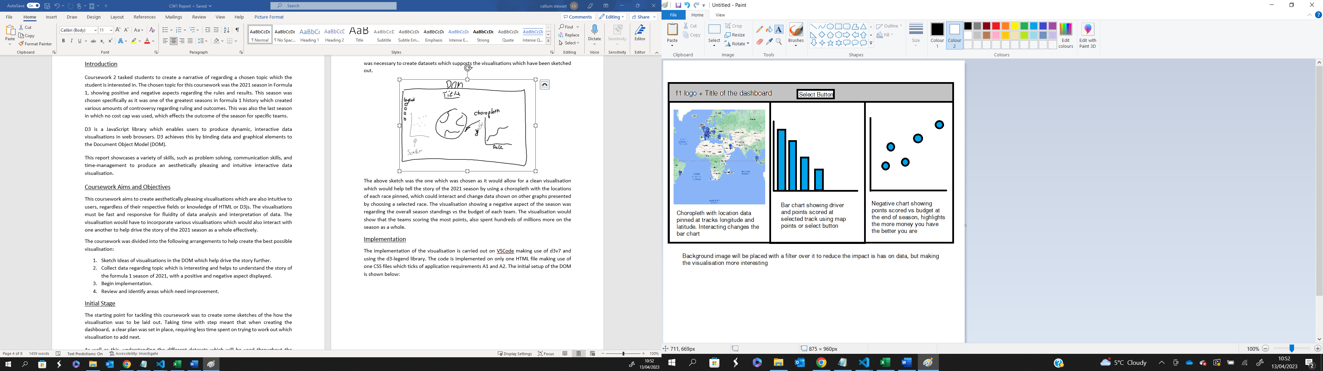

The above sketch was the one which was chosen as it would allow for a clean visualisation which would help tell the story of the 2021 season by using a choropleth with the locations of each race pinned, which could interact and change data shown on other graphs presented by choosing a selected race. The third visualisation showing a negative aspect of the season was a scatter graph, which compared each team’s budget and the points which they achieved in the season. The visualisation identifies that the teams scoring the most points, also spent hundreds of millions more on the season as a whole.

Implementation

The implementation of the dashboard is carried out on VSCode making use of d3v7. The code is implemented on only one HTML file making use of one CSS file which ticks of application requirements A2. The dashboard also used only 1 html page, A3. The initial setup of the DOM is shown below:

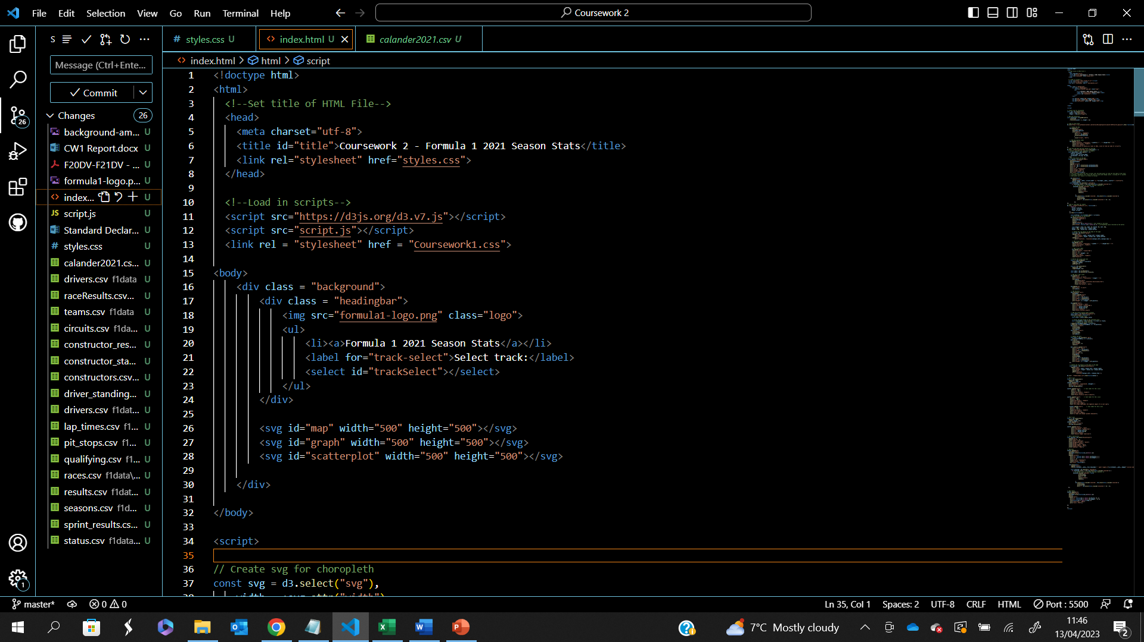

In this section of code, the title of the webpage was set up, and the scripts required are imported. The overall body of the page is created, which contains various div and svg elements. The div element background is at the top of the hierarchy, which stores the background image for the page. The next element creates an element acting as the heading bar, containing the formula 1 logo and the title of the page, alongside the select button. This was stored as a list and using CSS, elements are easily changed. Doing this helps drive home the theme of the dashboard as formula 1 related, A1.

Setting up a CSS file helped reduce hard coding in the main script. Comparing this too the first coursework, there is a lot more present in this section which has helped to keep the uniform colour scheme of the dashboard which adds to the aesthetics. Here we are able to change all visuals quickly and reduces the length of the html file.

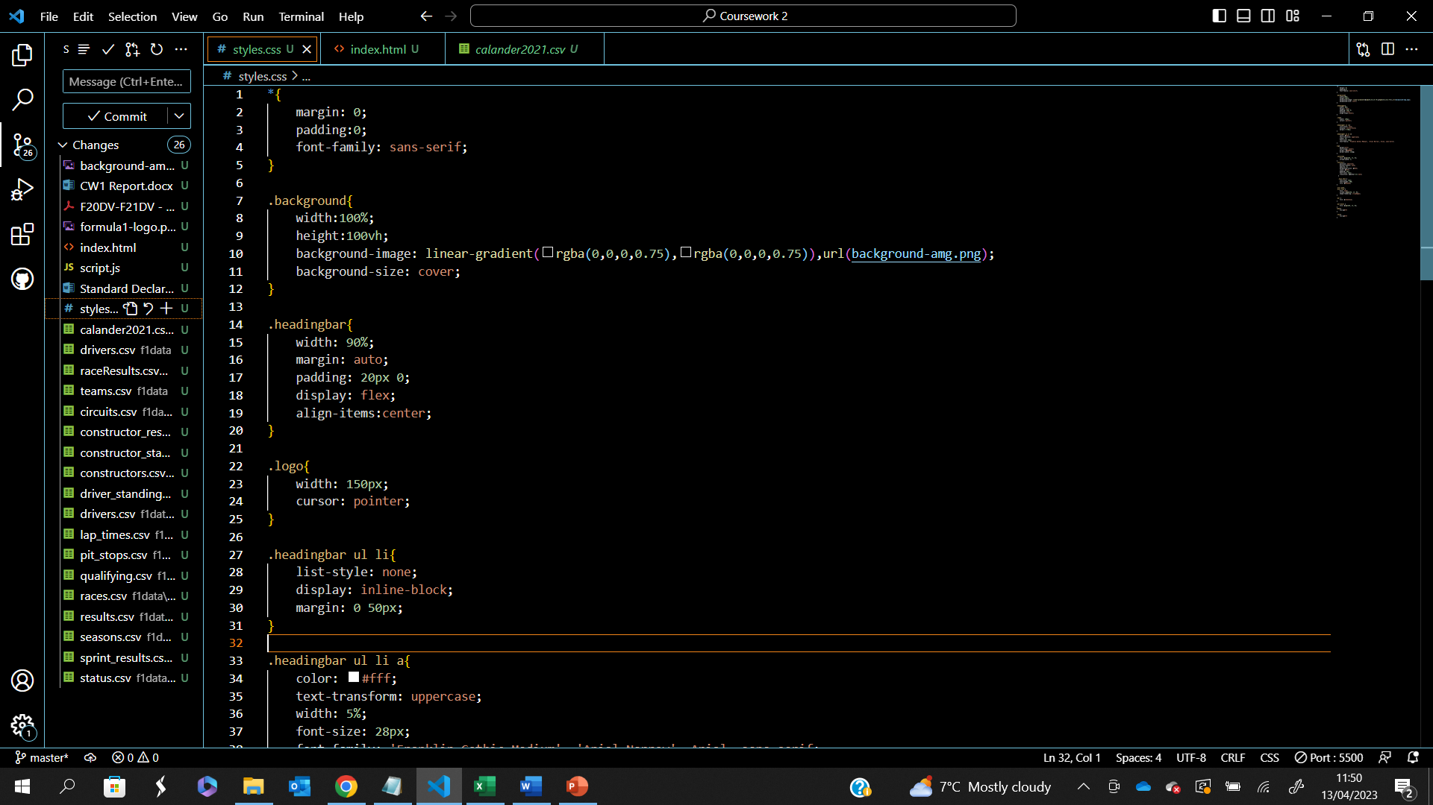

Beginning the main script, the first visualisation used was a choropleth, positioned to the left of the dashboard. This choropleth would be in Mercator format and would show the racetracks of each track for the 2021 calendar as points which are interactive on the map.

The first part of the code deals with initialising the map the first svg element. This process is fairly straightforward and I was able to reduce the amount of code used compared to my coursework 1 example.

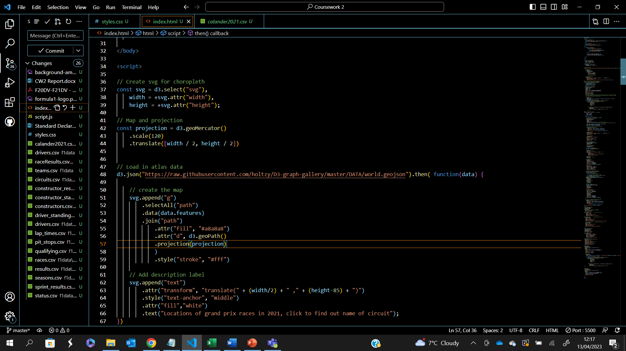

After the map was implemented, the next step was to add the points of interest to map, to do this the longitude and latitude points given by the csv file for each track were converted into a number, and these points were run through the projection. This would return the x and y coordinates for the circles centre and would be appended to the map.

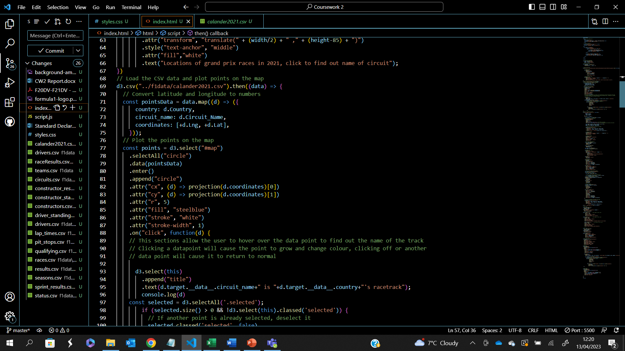

The interactive aspect of this was then carried out. When the data point is clicked, the circle would grow and change colour, making it clear to the user which track has been selected. Only one track can be selected at a time, so by either clicking the same point again, or another track, the previous point would return to its resting state, and the new point would transform. This was also used to change the next graph, to highlight the race standings after the chequered flag.

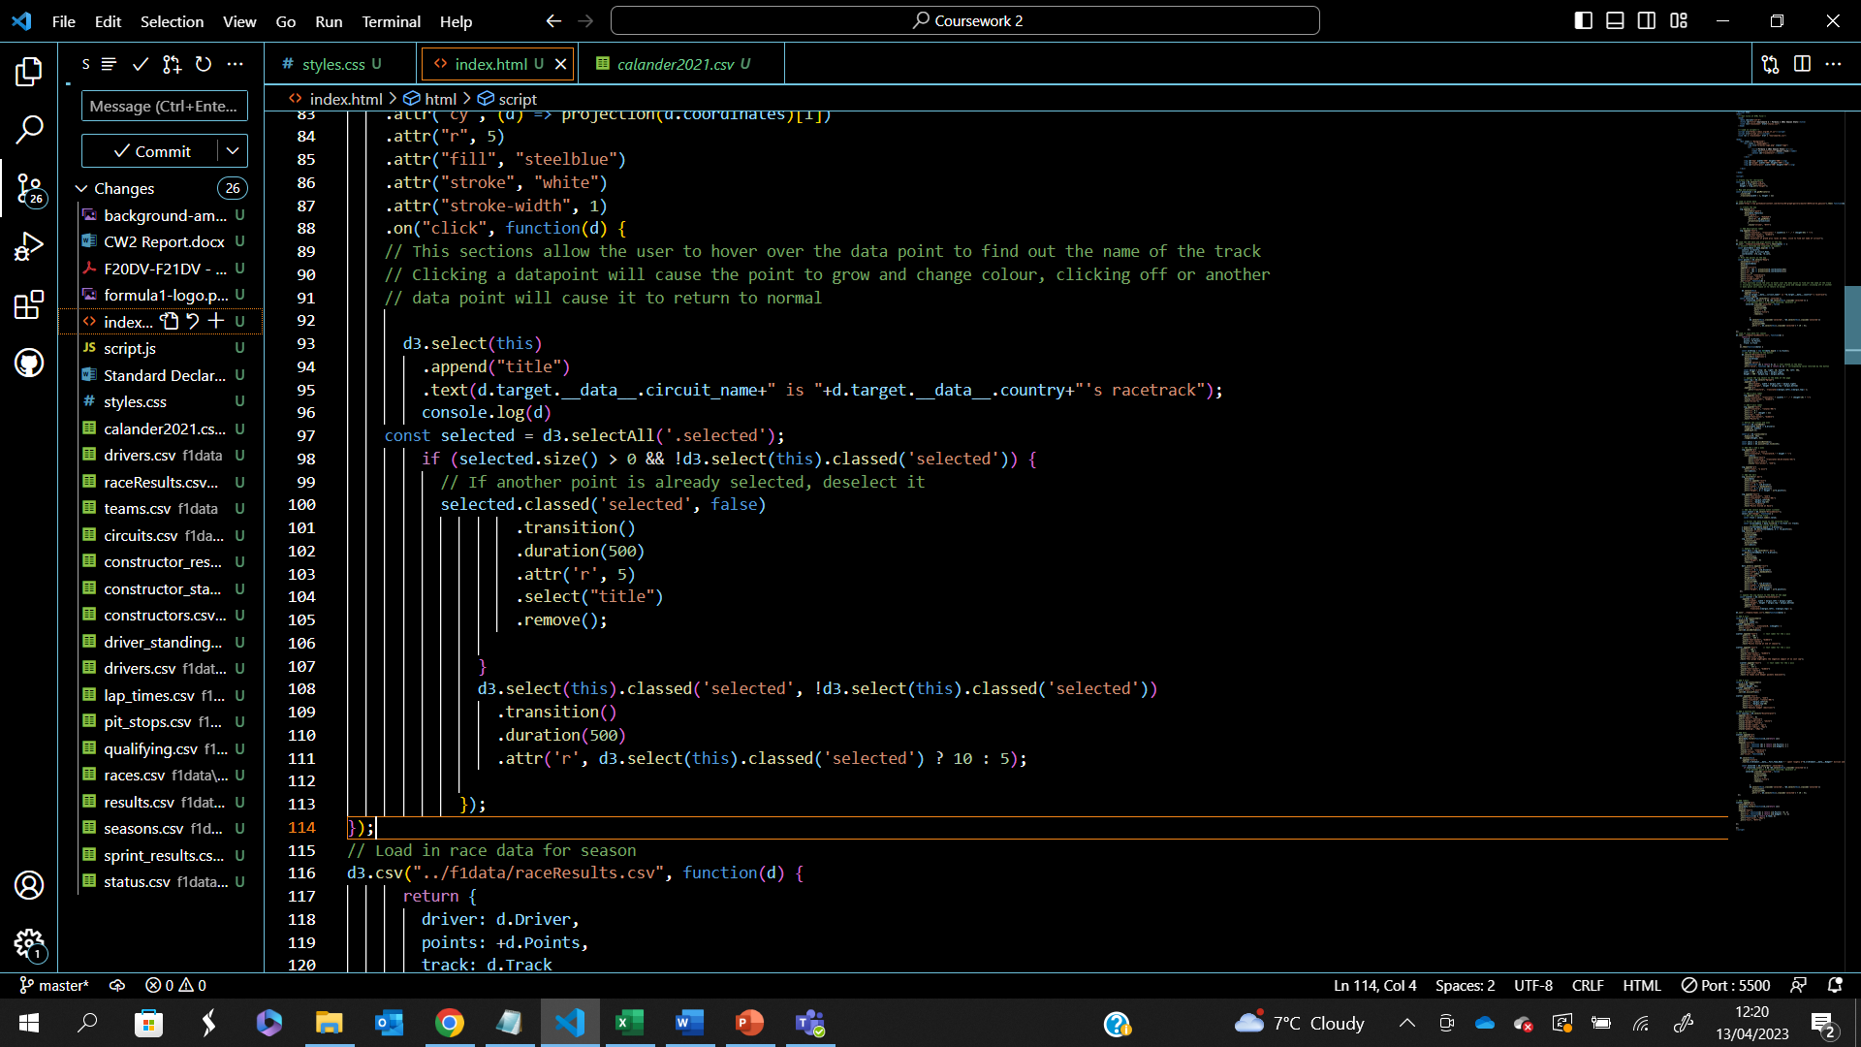

The next visualisation to implement was the results of each race. This was in the form of a bar chart to make it easy for the user to interpret the final positions of the drivers and the number of points scored. A select button was introduced here to give users the choice to go through the races in order of the calendar but could also change the chart by choosing the pinpoint on the map.

To begin with, the data is read and stored the track, points, and the driver. The track was then stored into the select button.

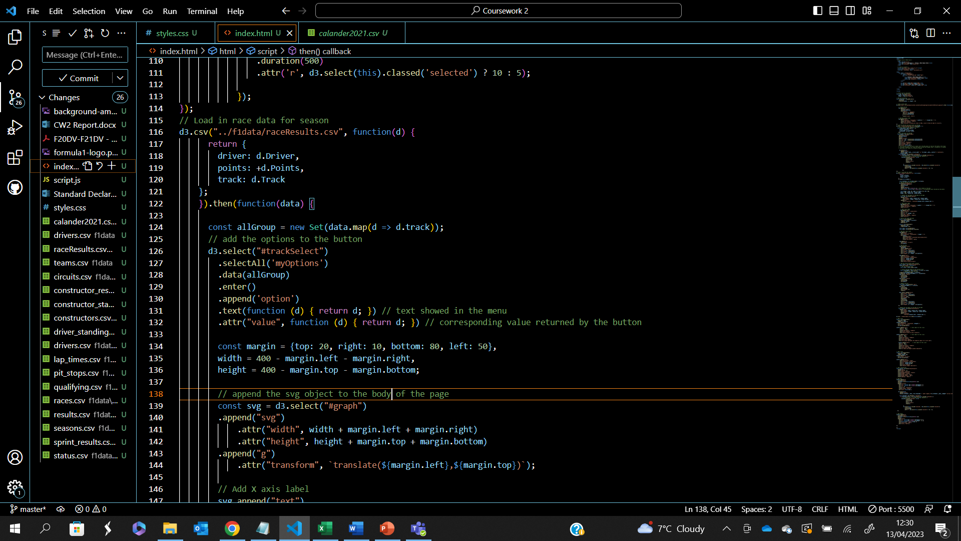

After this, the axes of the graph were appended to the bar charts svg, making sure that the scales were appropriate to the data. These were as a class so that the axes could be updated in the CSS file.

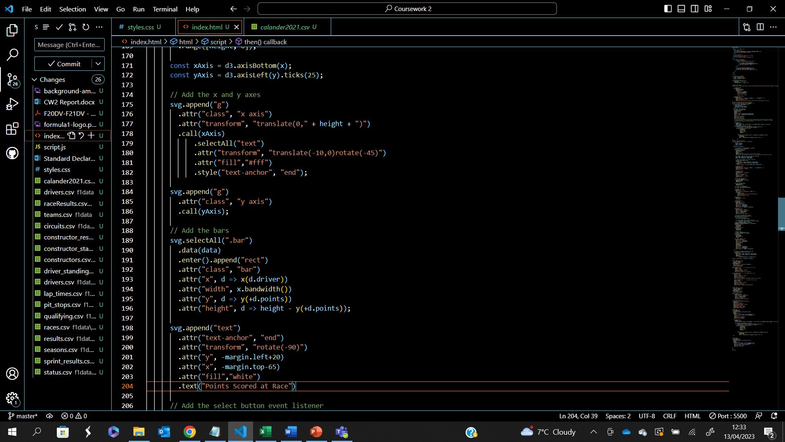

The bars were then created and assigned to the points and the driver and would be shown in the correct order of the race result, out of 20 places.

After this, an event listener was created, and would read the track select, which would update the bars from the chosen list of tracks using a smooth transition as demonstrated in the video. The user could then click the track from the map to update the chart, or by using the select button at the top of the html.

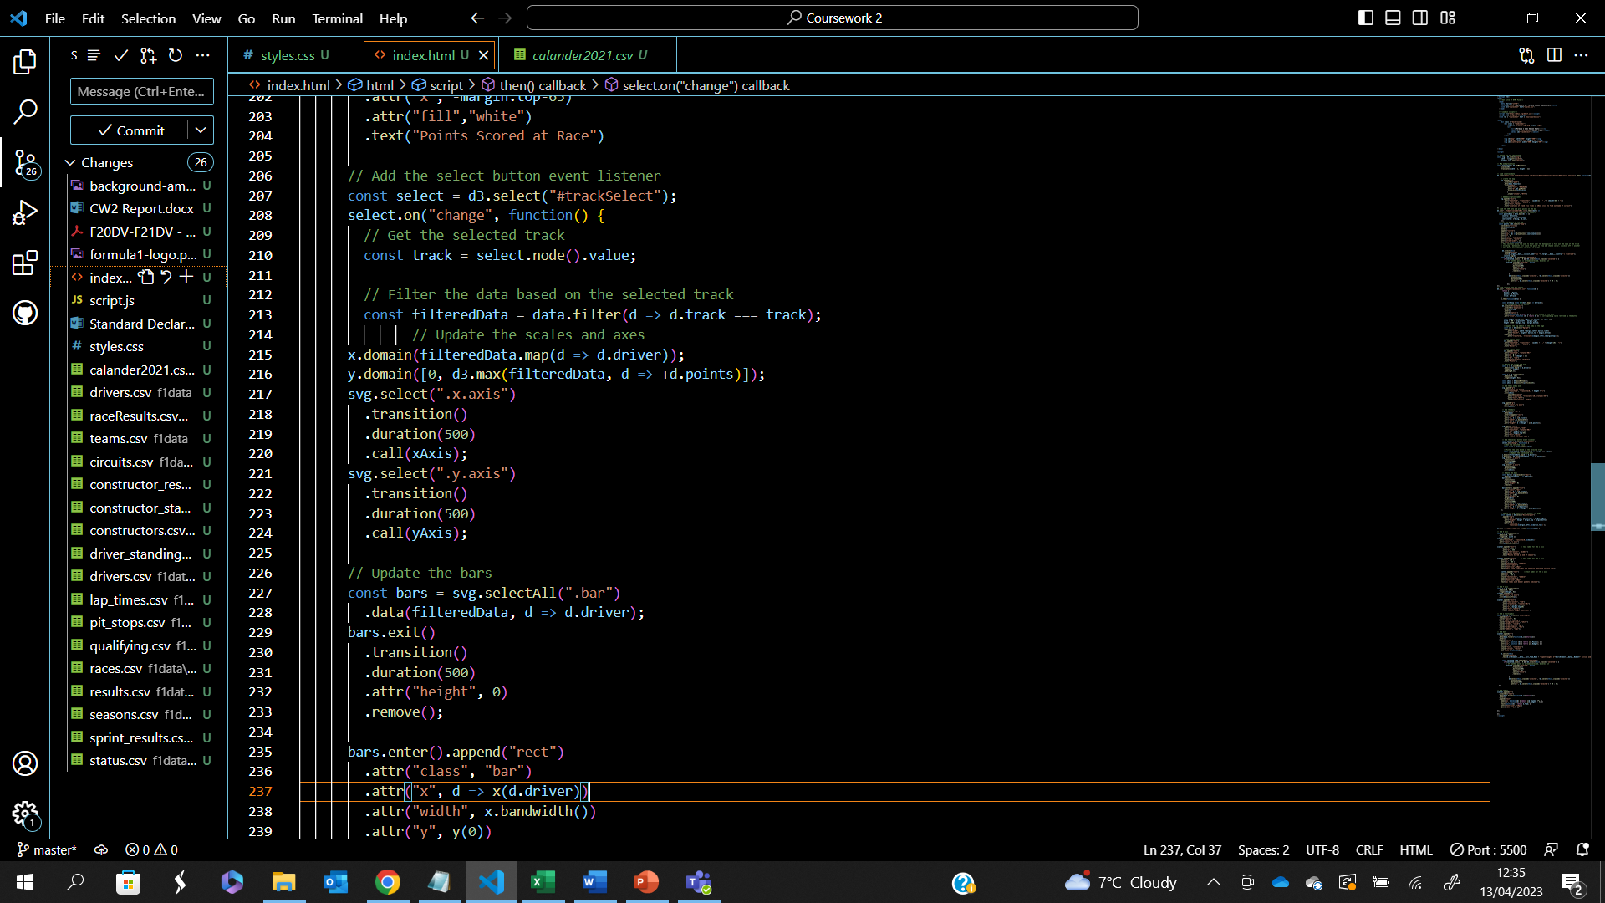

The final chart was a scatter graph which highlighted the negative aspect of the 2021 formula 1 season. The chart was created in a similar fashion to the bar chart, with the same code used to create the axes with slightly different variables.

The main difference was that instead of appending bars, dots were appended depending on the size of the budget and points.

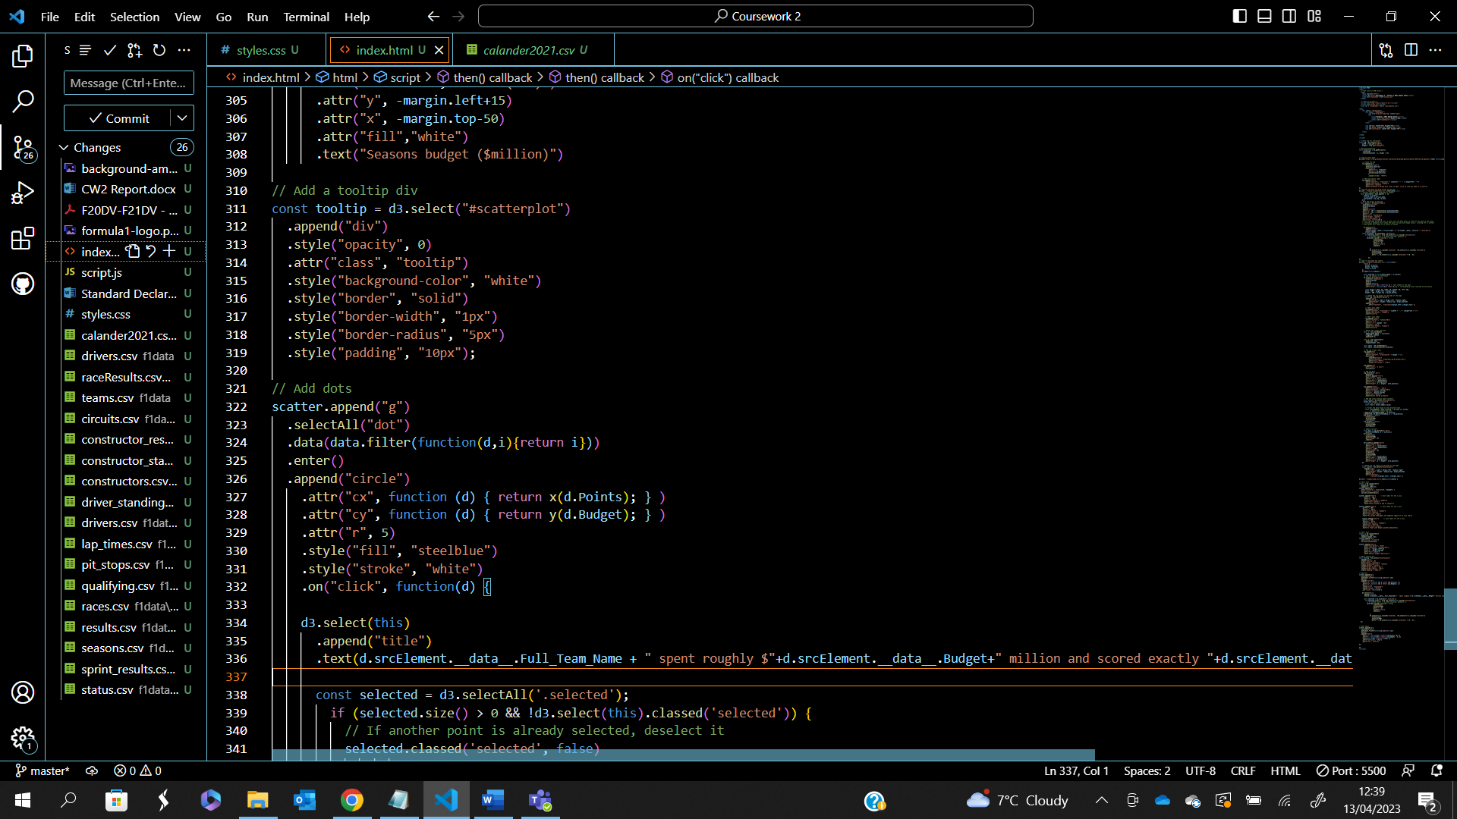

This visualisation also included interactivity by being able to select the dots, with more information being returned by the tooltip, as well as clearly showing the selected dot similar to the map visualisation.

Overall, three different interactive visualisations are used, with 1 showing a positive facet of the globality of formula 1, with 1 negative facet of the season in that the sport is a pay to win game, A4, A5, A6, A7.

Results

The following image demonstrate the overall dashboard after the implementation was completed. The graphic is clear and laid out in a structed manor with a well established theme. The colours used work well together but do not distract from the data shown. The text is clear and easily readable, making the overall dashboard simple to navigate and interpret.

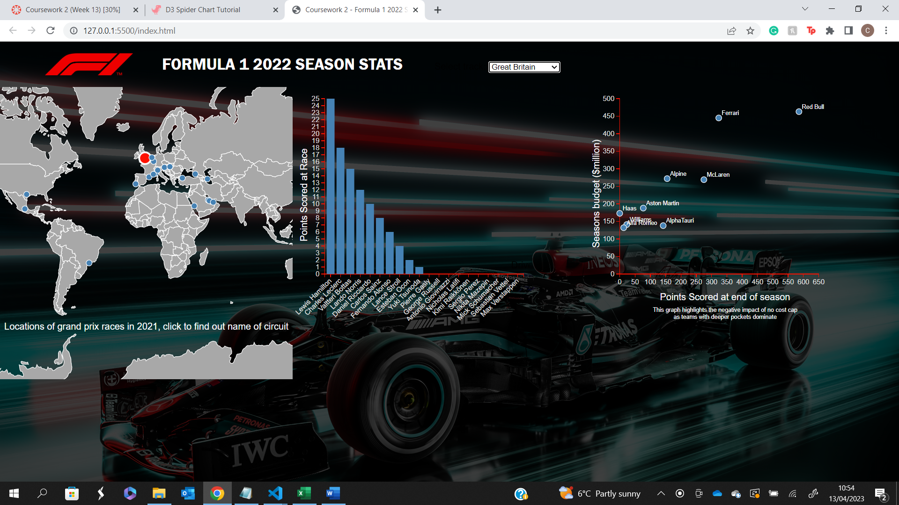

The following images show the interactivity between the choropleth and the bar chart. The user can select the circuit on the map to find out the final race standing. The first picture demonstrates the track Monaco and highlights it on the map. The tooltip pointer allows the user to read the tracks name and the country it is in. The bar chart is also interactive, where a user can however over the driver’s bar to highlight is clearly to see how many points the received from that race. The second example highlights the interaction between the map and the bar chart, where the selected track this time is the USA, showing the race results for this grand prix.

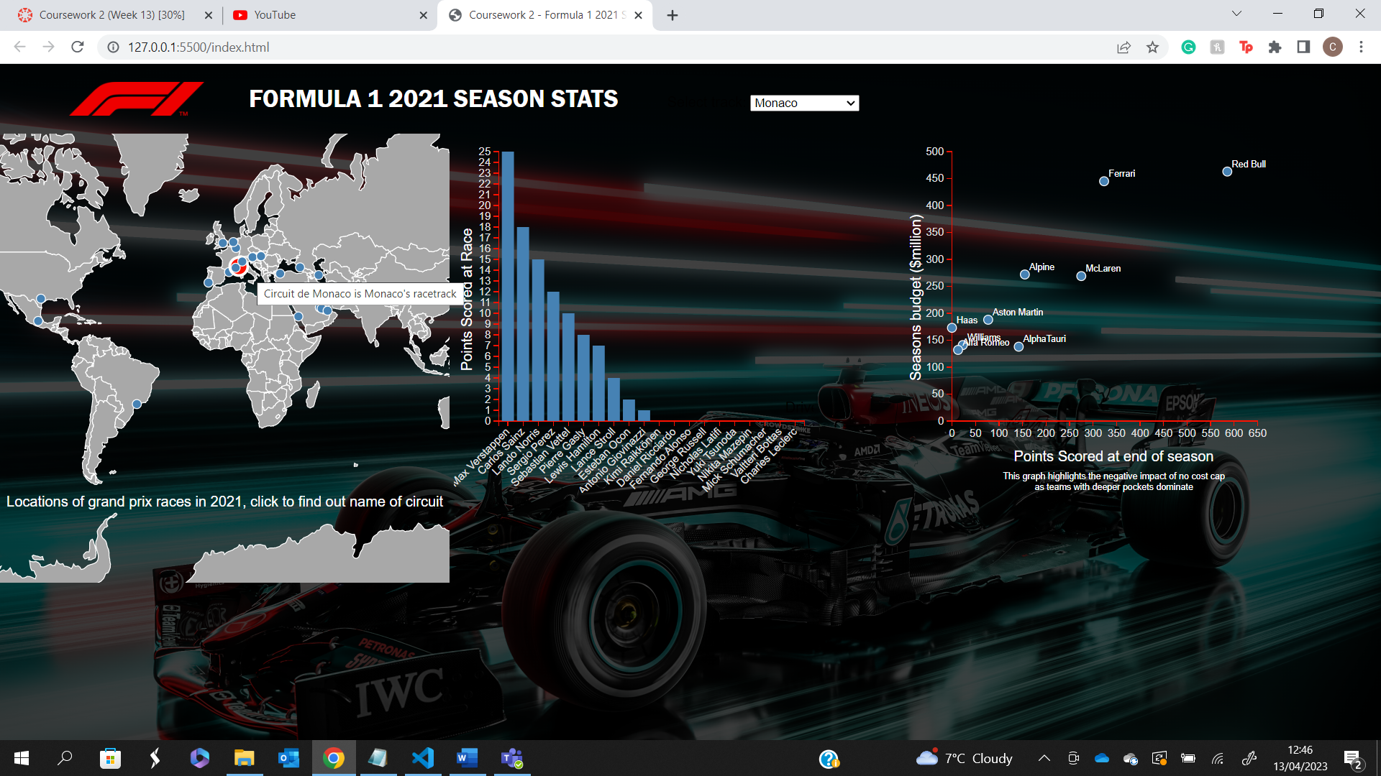

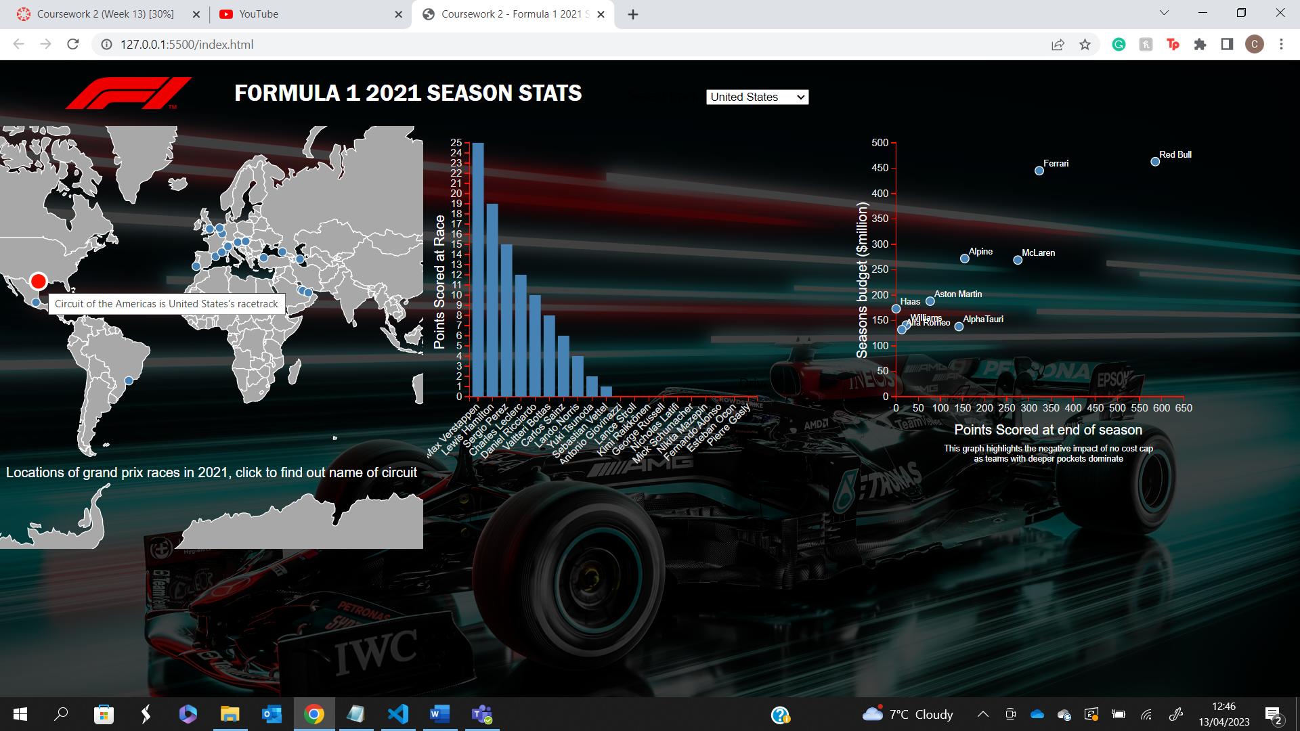

The following image shows the scatter graph, which shows formula 1 in a more negative facet. The graph aims to show each team competings budget for the season and the overall points which they scored. The graph clrealy shows that before the budget cap was introduced, the sport was considered a pay to win sport.

The visual allows users to click on each team to find out there overall spending of the 2021 season along with the total points which they had scored. A clear conclusion can be drawn from this, showing that it is true that having deaper pockets results in a more successful season.

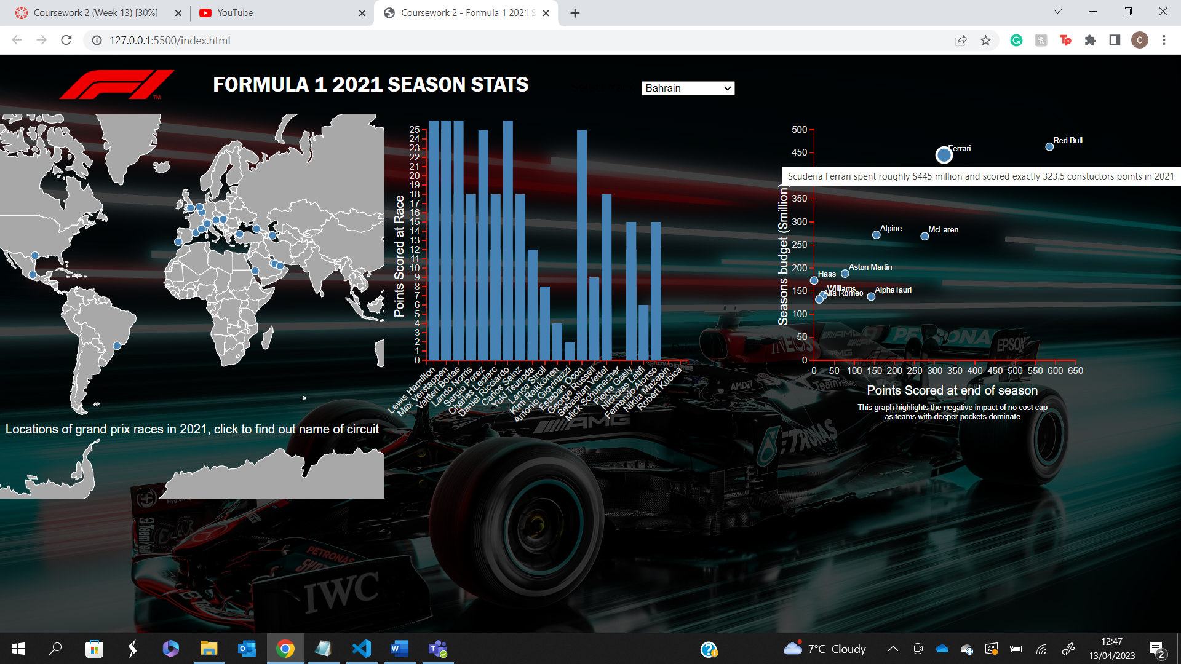

Conclusions

Overall, the dashboard created captures key information regarding the season of 2021, with the outcomes of each race displayed, the number of points scored by each driver, and the overall constructors’ points at the end of the season. The interactive aspects of the dashboard are smooth and work well together, enabling users to explore the data freely and at the pace they wish.

Future Work

With the visualisation meeting most requirements listed in the application requirements, there are various aspects which could be implemented in future:

1. The dashboard could be extended to house a spider diagram which shows track information such as DRS Zones, number of corners, the length of the circuit etc.. This was attempted however the output was not clear so it was decided that it would not be used.
2. Increase the complexity of the visualisations.
3. Add a bit more interactivity between the visuals.
4. Adapt the code so it could handle more than 1 specific season of formula 1.